**Bahria University, Lahore Campus**

Department of Computer Sciences

Lab Journal 01

**(Spring 2023)**

|  |  |  |
| --- | --- | --- |
| Course: | **Computer Architecture & Organization Lab** |  |
| Course Code: | CEL 221 | Max Marks: 30 |
| Faculty’s Name: | Maryam Munawar | Lab Engineer: |

Name: _AFFAN AHMAD _ Enroll No: 03-134221-003_

## Lab Tasks:

### Task1 10 Minutes

Write any three temporary registers, argument registers

Temporary is :

T0,t1,t2,t3,t4,t5,t6,t7.

Argument is :

A0,a1,a2,a3.

### Task2 10 Minutes

Tte3ett

Open the MARS 4.5 IDE

Write the above code in new file and save the file with extension ***.asm*** First_program.asm

Then go to the RUN tab.

Assemble the ***.asm*** file using assemble command (F3).

Run the exe file using Go command (F5).

Observe the output

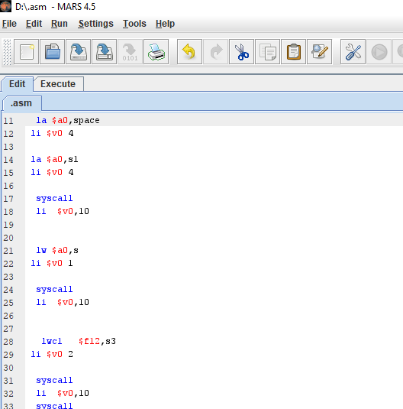

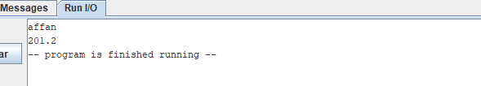

### Task3 10 Minutes

Write a MIPS Program to get a user age and Number. Expected output:

abcdef

1233

4B

.data

space: .asciiz "\n"

s: .word 20

s1:.asciiz "age is :"

s3: .asciiz "0334792243"

s4: .asciiz "Number is :"

.text

main:

la $a0,s1

li $v0 4

syscall

lw $a0,s

li $v0 1

syscall

la $a0,space

li $v0 4

syscall

la $a0,s4

li $v0 4

syscall

la $a0,s3

li $v0 4

syscall

li $v0,10

syscall

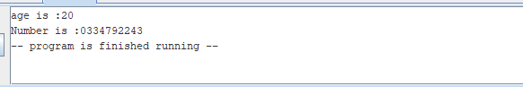

**Lab Grading Sheet :**

|  |  |  |  |
| --- | --- | --- | --- |
| **Task** | **Max Marks** | **Obtained Marks** | **Comments(*if any*)** |
| 1. | 10 |  |  |
| 2. | 10 |  |  |
| 3. | 10 |  |  |
|  |  |  |  |
| **Total** | **30** |  | **Signature** |

**Note : Attempt all tasks and get them checked by your Instructor**